Contents
1. Introduction 2
2. Programming Manual: Configuring the Code for the Core Functionalities 2
3. Development and Testing Environment 5
4. Integration Progress 5
5. Network Infrastructure and Security Configuration 5
5. Appendix 7
5.1 Database 7
5.2 Webpage 11
6. Conclusion 17

1. Introduction
The Clinic Management System (CMS) project intends to digitalize and streamline critical healthcare administrative operations such as user registration, patient onboarding, appointment scheduling, billing, and notifications. Earlier weeks (Weeks 3 and 4) were spent mostly on developing the MySQL database schema, implementing backend logic for user and patient modules, and arranging secure access via role-based permissions. The initial system implementation provided the foundation for entity relationships, session-based security, and core database functions.
Weeks 5 and 6 saw great development in the project as critical clinical functionalities were implemented. These include a simple patient billing system, support for a wide range of healthcare services (e.g., consultations, lab tests, X-rays, MRIs, procedures, and medications), an invoice and payment management module, and email notifications for appointment confirmations, payment reminders, and vaccine alerts. These modules are now effectively integrated with the patient registration and appointment systems.
This report includes an overview of the code development, database integration, and testing environment used to connect these modules, as well as screenshots and organized documentation. The project is progressing toward a secure, user-friendly, and efficient clinical system for real-world use.

2. Programming Manual: Configuring the Code for the Core Functionalities

Module 1: User & Patient Management
- First functional requirement: user registration.
The user registration functionality is intended to enable the establishment of new user accounts with specified responsibilities, such as administrator, doctor, receptionist, and patient. The MySQL table Users has fields such as Username, PasswordHash, Role, Email, and CreatedAt. Unique limitations on username and email assure integrity, and PasswordHash is designed to securely store encrypted passwords. The establishment of this table establishes the foundation for safe user management.
- Second Functional Requirement: User Login (planned)
The user login mechanism will authenticate users by checking hashed passwords against PHP's password_verify() function. After successfully logging in, users will be forwarded based on their roles. This feature will use session-based security to prevent unwanted access. Though not yet deployed owing to XAMPP's technological limitations, the database is ready to handle this capability.
- Third functional requirement: patient registration.
The Patients table enables patient registration by assigning each patient a unique user ID. It contains fields like FullName, DOB, Gender, ContactNumber, and Address. Referential integrity is maintained by requiring a foreign key relationship between patients and users. This structure ensures that only registered users can be added as patients, hence improving data consistency.
- Fourth functional requirement: Appointment scheduling (planned).
The Appointments table will help patients schedule doctor visits more easily. It contains the AppointmentID, PatientID, DoctorID, AppointmentDate, AppointmentTime, and Status fields. Foreign key constraints require that PatientID and DoctorID appear in their respective tables. Although the frontend implementation is still pending, the backend database structure has been prepared.
- Fifth Functional Requirement: Patient billing system.
We created a basic billing module that dynamically calculates the total service expenses spent by a patient. The billing interface allows for the inclusion of various service items, including associated fees and tax (where appropriate). It automatically computes subtotals and total due amounts.
- Sixth functional requirement: service management.
A services module was developed to manage clinic offerings like
  - Consulting Services
  - Procedures
  - Medicines
  - X-Rays
  - Labs
  - MRI scans
Each service is identified by a name, description, category, and unit pricing and can be selected during billing or appointment setup.
- Seventh functional requirement: invoice and payment handling.
We introduced invoice production and payment tracking, which are directly tied to patient services. Key Capabilities:
  - Create an invoice at the time of service confirmation.
  - Track the payment status (paid, pending).
  - Maintain the invoice history for each patient.
- Eighth functional requirement: Email notification system.
Although SMS functionality was first discussed, we chose email notifications due to integration feasibility. Notifications are generated for:
  - Appointment confirmations
  - Payment Reminders
  - Upcoming vaccine doses (for pediatric patients).
  - This functionality sends transactional emails using the built-in PHP mail() function.

3. Development and Testing Environment

Component | Description
Database | MySQL (via phpMyAdmin)
Development Stack | XAMPP (PHP, Apache, MySQL)
IDE | Visual Studio Code (planned)
Testing | phpMyAdmin interface
Network | Localhost (127.0.0.1)
Security | Password hash fields, unique constraints, and ENUM roles

4. Integration Progress:
The new functionalities are now integrated into the Patient Registration and Appointment & Scheduling modules. Patients can now:
- Register in the system
- Book appointments with selected services
- Receive billing and invoice info
- Get notified via email

5. Network Infrastructure and Security Configuration
To ensure relational integrity, the database enforces foreign key constraints. The Users table controls role-based access through ENUM roles. The technique is intended to hash passwords before saving them in a database. HTTPS support, server-side input validation, and session-based login control are among the planned network setups. Although not yet implemented, the backend architecture considers typical cybersecurity protocols.
Firewall
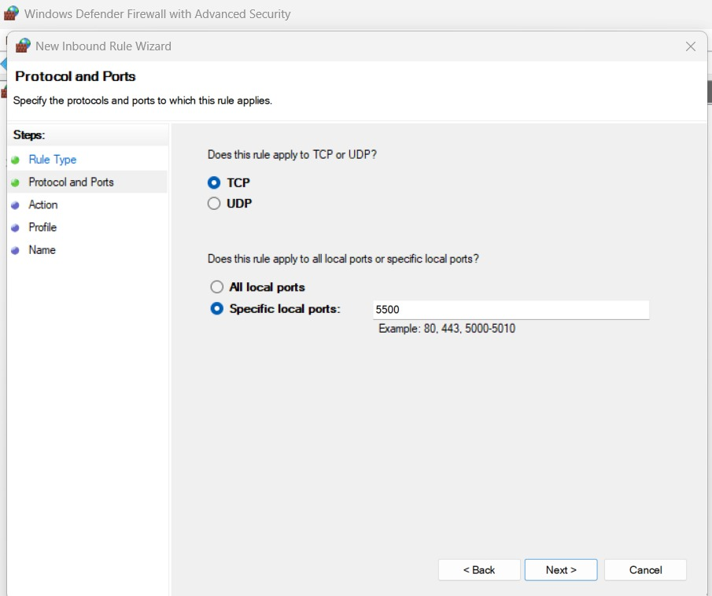

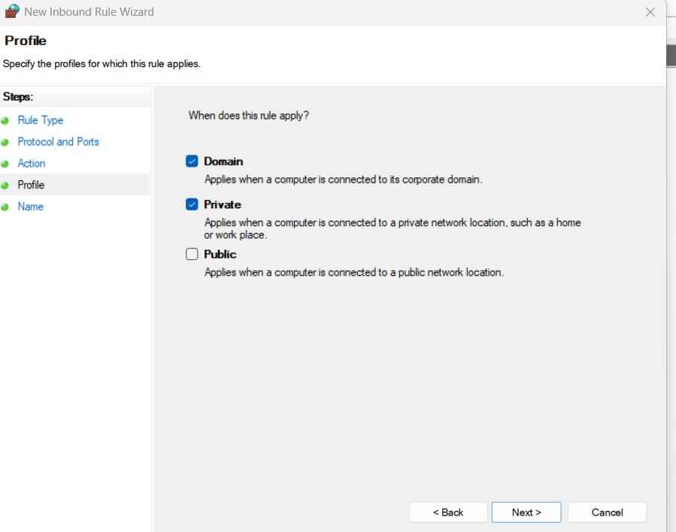

5. Appendix

5.1 Database
A. Database Structure in phpMyAdmin
This screenshot shows the list of tables created for the Clinic Management System project.
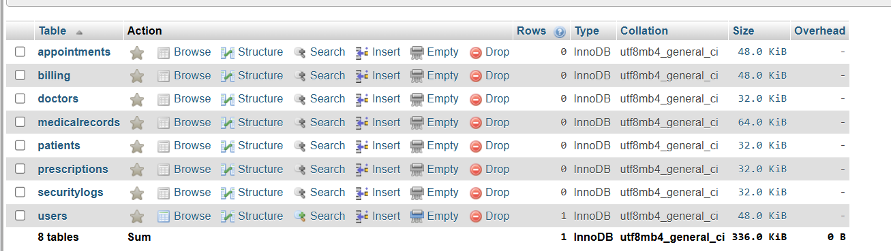

B. Table Structure – Users Table
Code:
CREATE TABLE Users (
UserID INT AUTO_INCREMENT PRIMARY KEY,
Username VARCHAR(50) UNIQUE NOT NULL,
PasswordHash VARCHAR(255) NOT NULL,
Role ENUM('Admin', 'Doctor', 'Receptionist', 'Patient') NOT NULL,
Email VARCHAR(100) UNIQUE,
CreatedAt DATETIME DEFAULT CURRENT_TIMESTAMP
);
Screenshot

C. Table Structure – Patient Table
Code:
CREATE TABLE Patients (
PatientID INT AUTO_INCREMENT PRIMARY KEY,
UserID INT NOT NULL,
FullName VARCHAR(100) NOT NULL,
DOB DATE,
Gender ENUM('Male', 'Female', 'Other'),
ContactNumber VARCHAR(15),
Address TEXT,
FOREIGN KEY (UserID) REFERENCES Users(UserID)
);
Screenshot

D. Inserting dummy data in the doctor table
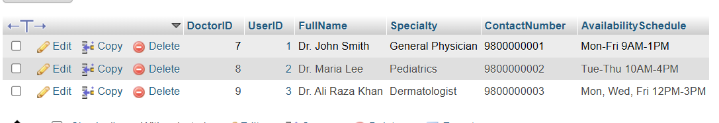

E. Appointment table

Code:
CREATE TABLE Appointments (
AppointmentID INT AUTO_INCREMENT PRIMARY KEY,
PatientID INT NOT NULL,
DoctorID INT NOT NULL,
AppointmentDate DATETIME NOT NULL,
Status ENUM('Scheduled', 'Completed', 'Cancelled') DEFAULT 'Scheduled',
ConsultationMode ENUM('InPerson', 'Online') DEFAULT 'InPerson',
Notes TEXT,
FOREIGN KEY (PatientID) REFERENCES Patients(PatientID),
FOREIGN KEY (DoctorID) REFERENCES Doctors(DoctorID)
);
Screenshot:

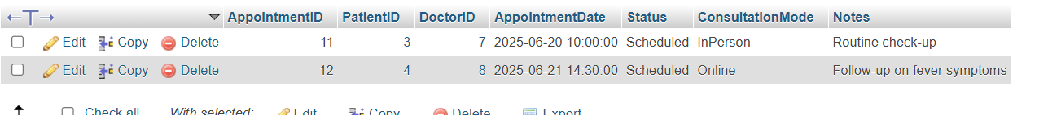

F. Medical records table
Code:
CREATE TABLE MedicalRecords (
RecordID INT AUTO_INCREMENT PRIMARY KEY,
PatientID INT NOT NULL,
DoctorID INT NOT NULL,
AppointmentID INT NOT NULL,
Diagnosis TEXT,
ConsultationNotes TEXT,
RecordDate DATETIME DEFAULT CURRENT_TIMESTAMP,
FOREIGN KEY (PatientID) REFERENCES Patients(PatientID),
FOREIGN KEY (DoctorID) REFERENCES Doctors(DoctorID),
FOREIGN KEY (AppointmentID) REFERENCES Appointments(AppointmentID)
);
Screenshot:
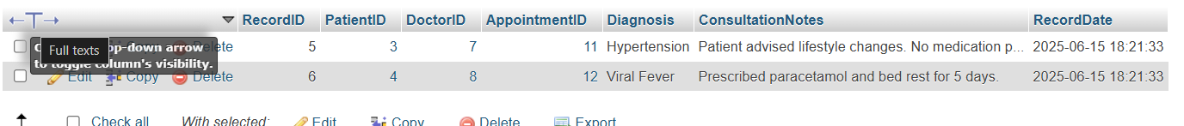

5.2 Webpage
Registration page
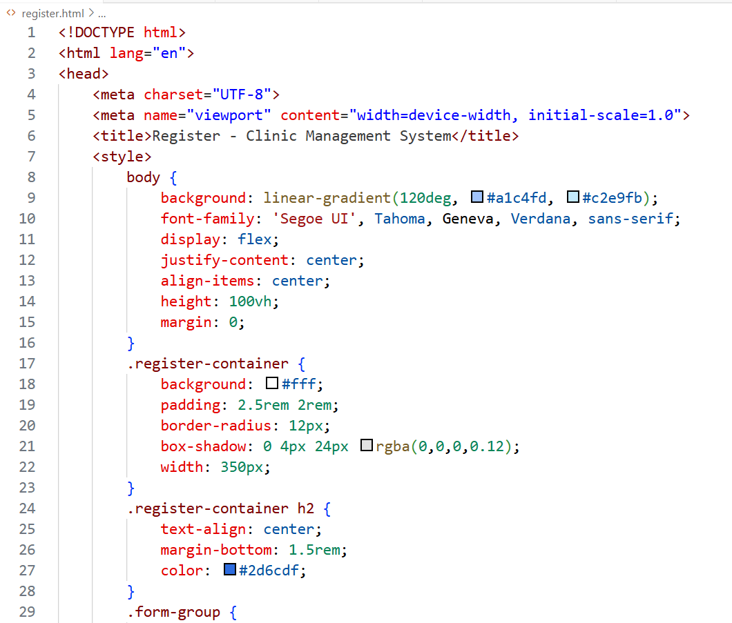
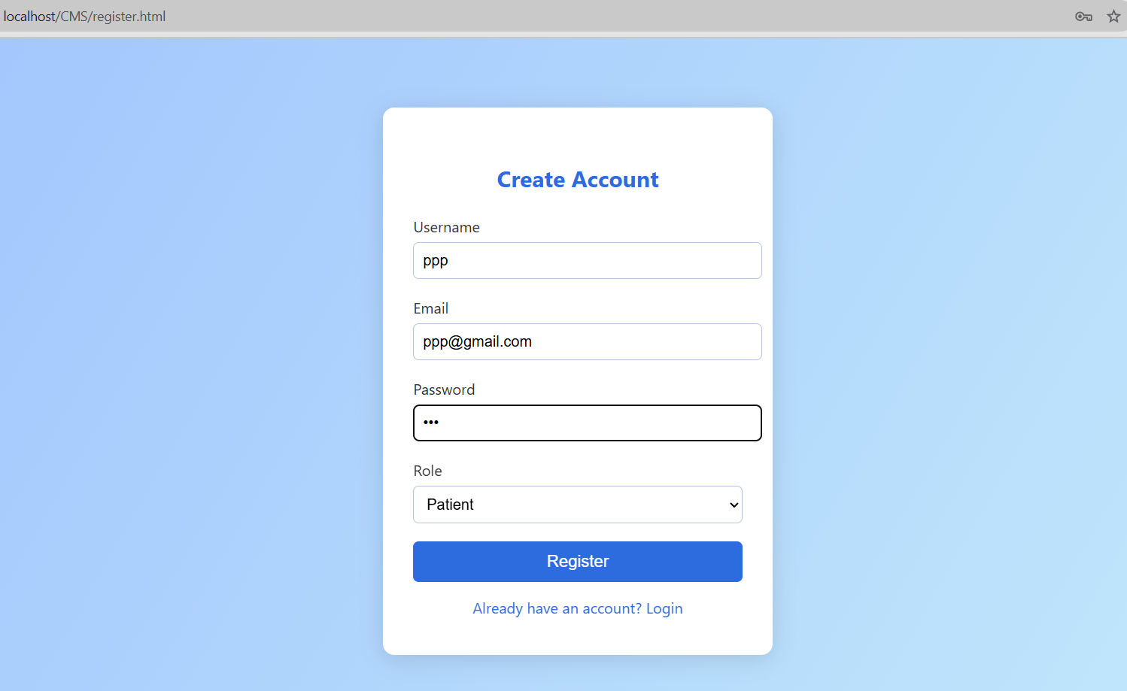
Login page
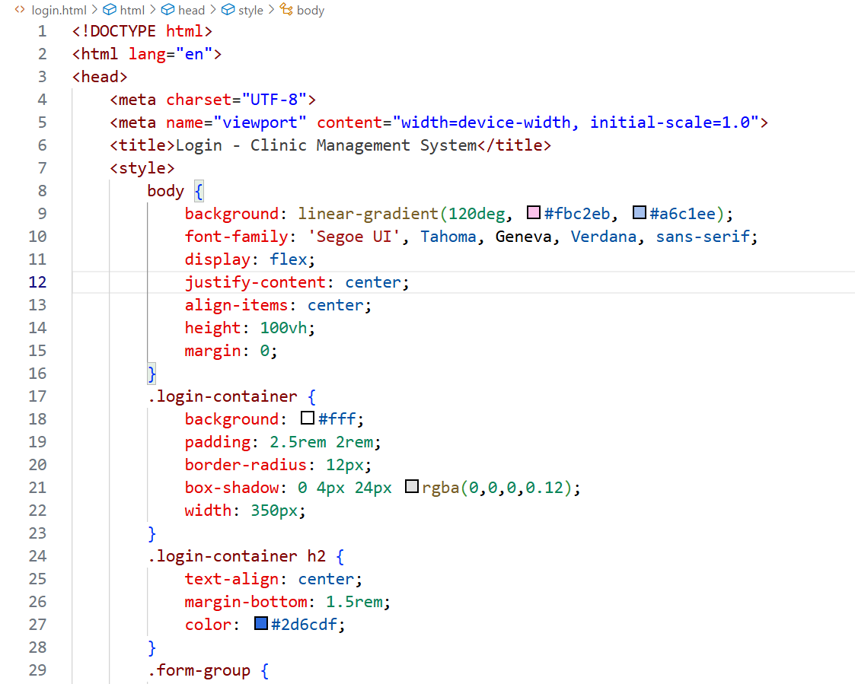
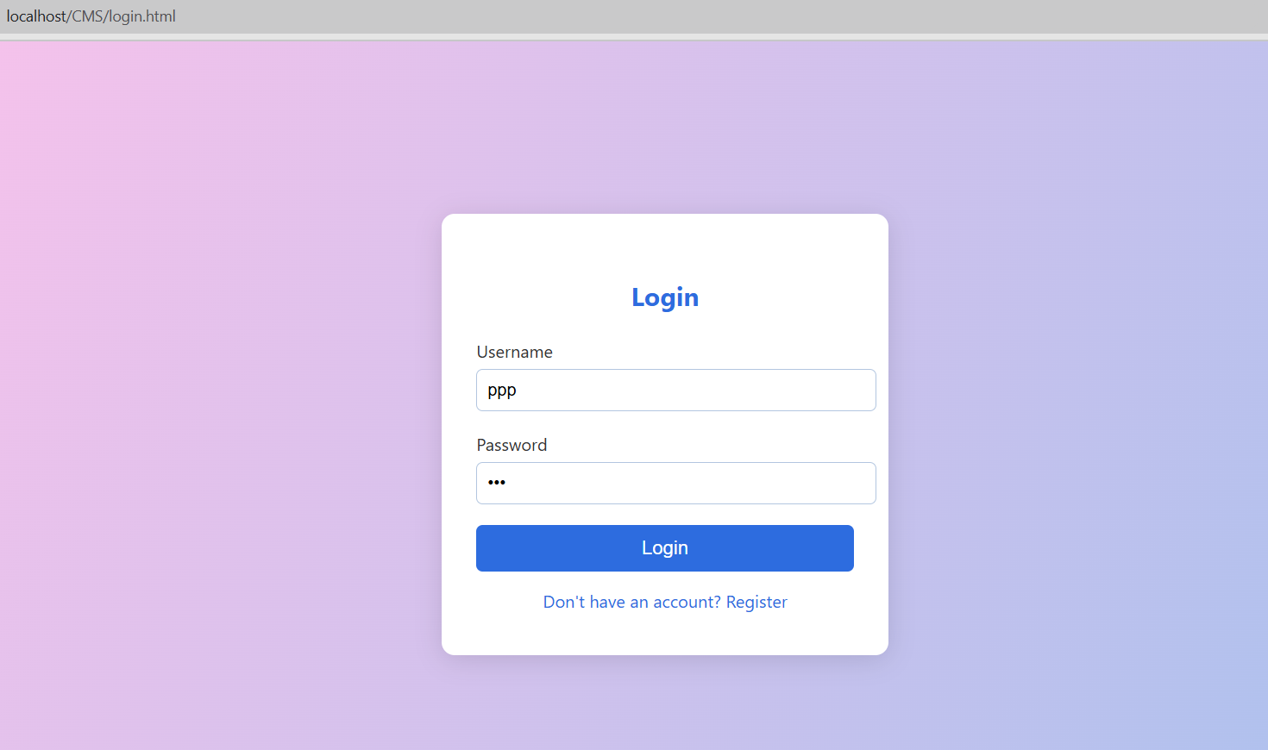
Patient dashboard
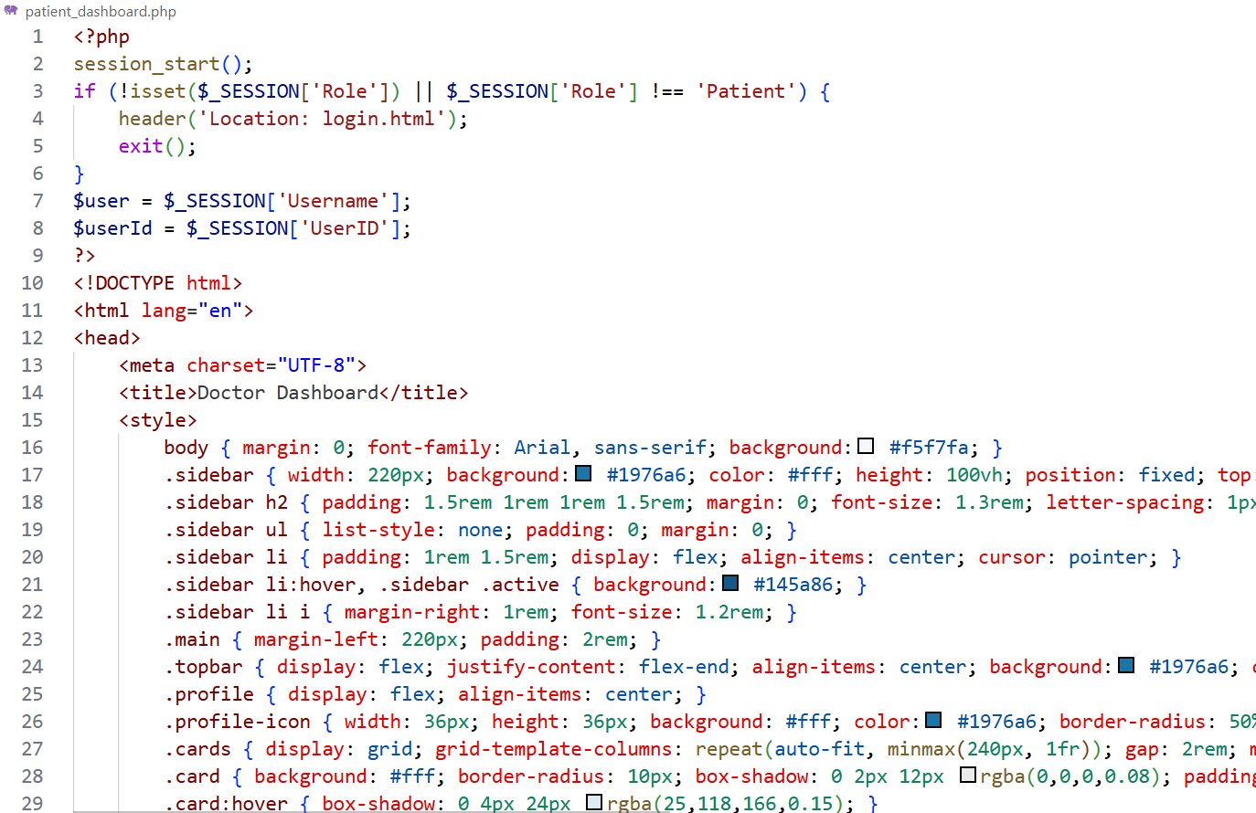

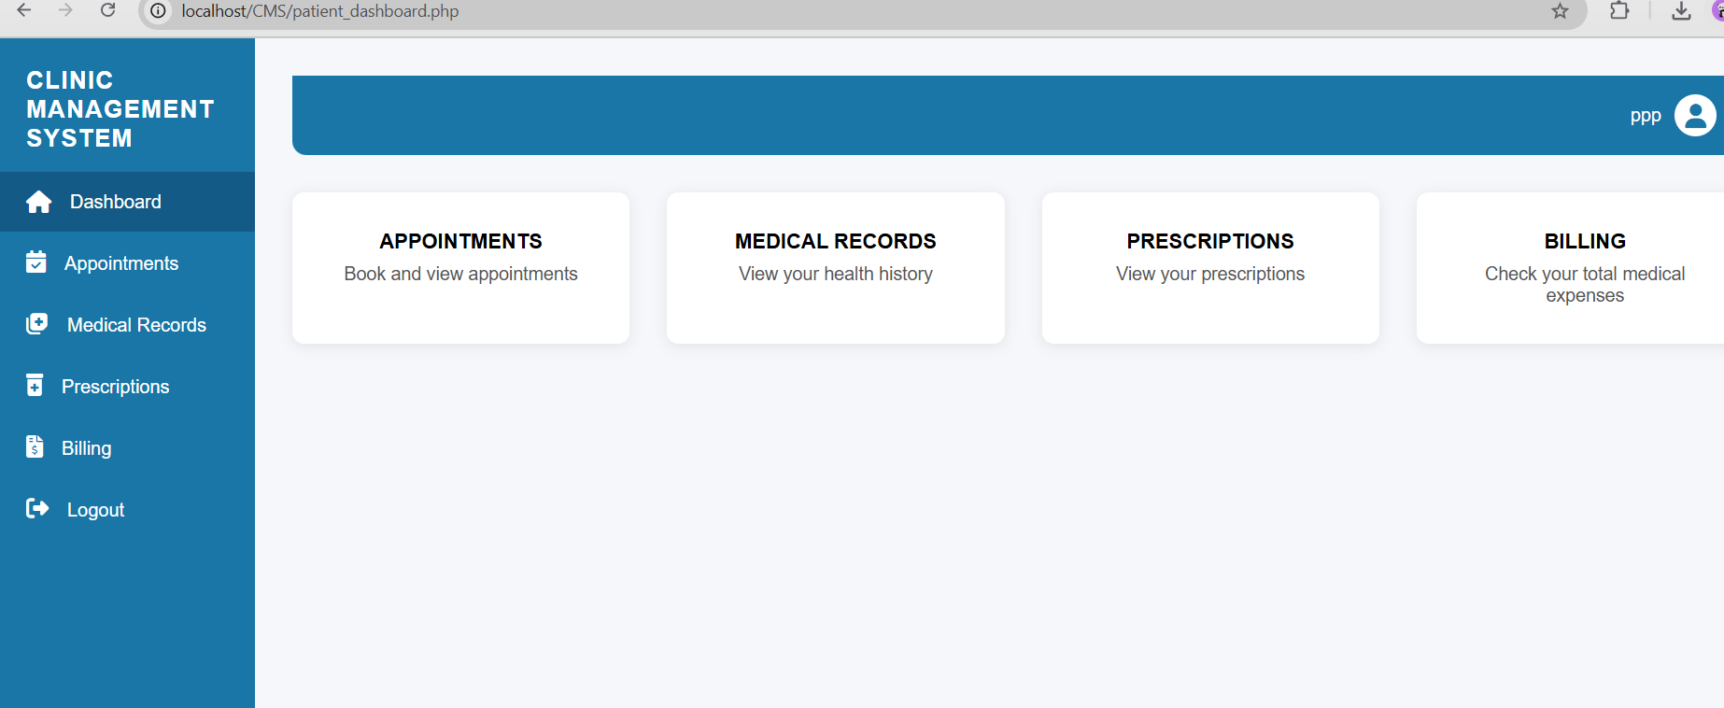

Booking appointment
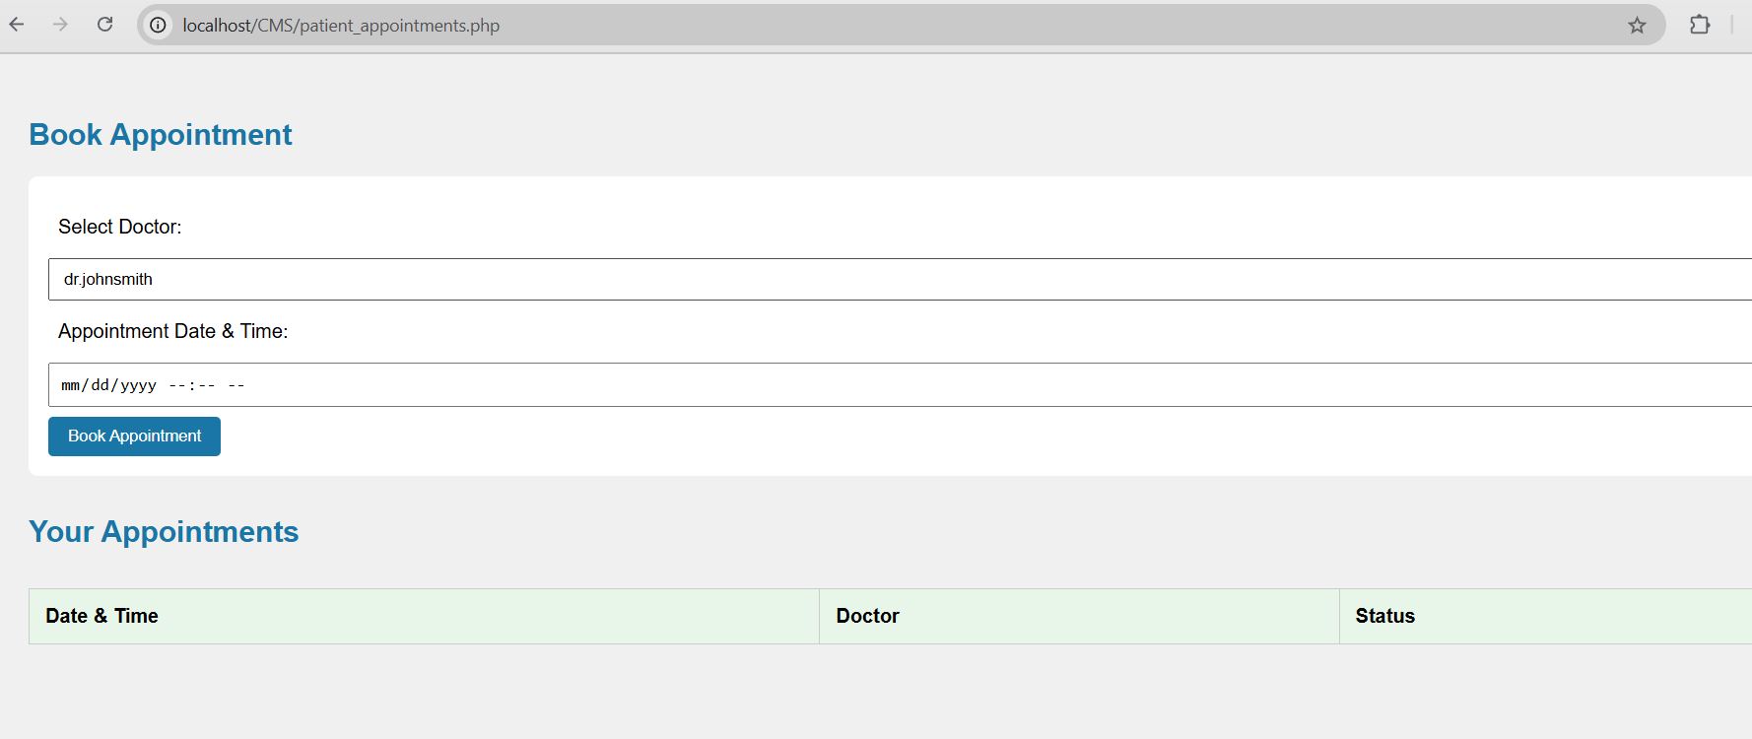
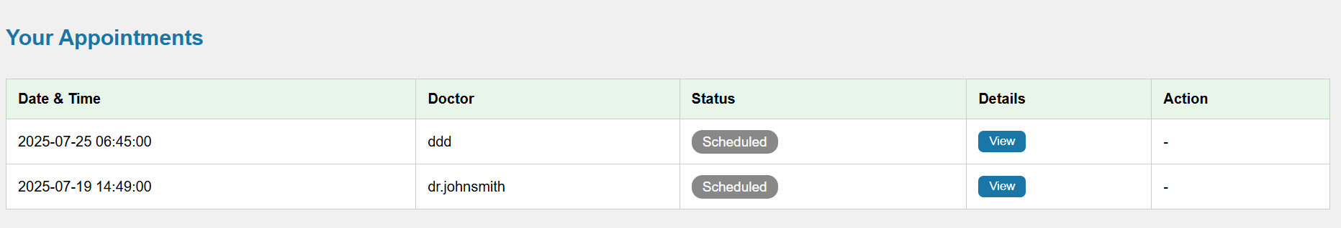
Doctor’s dashboard
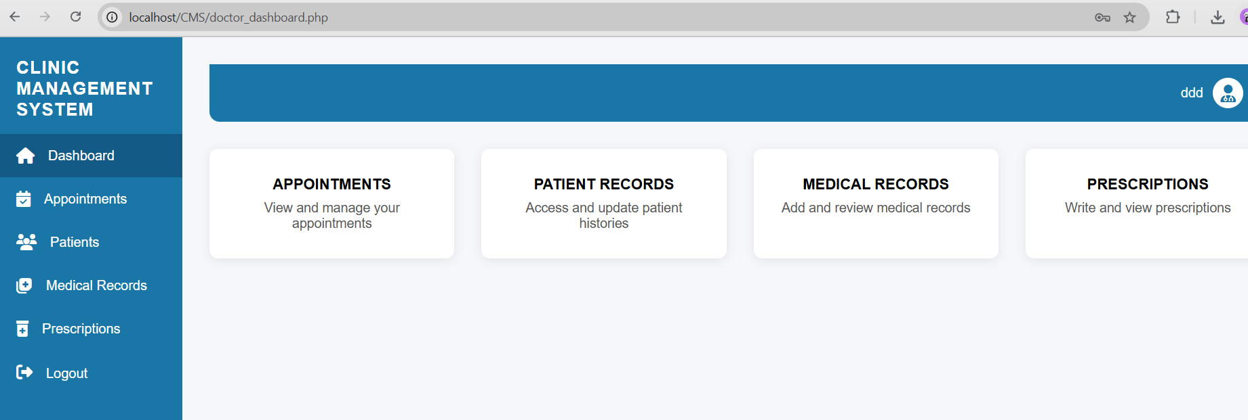

Appointment list
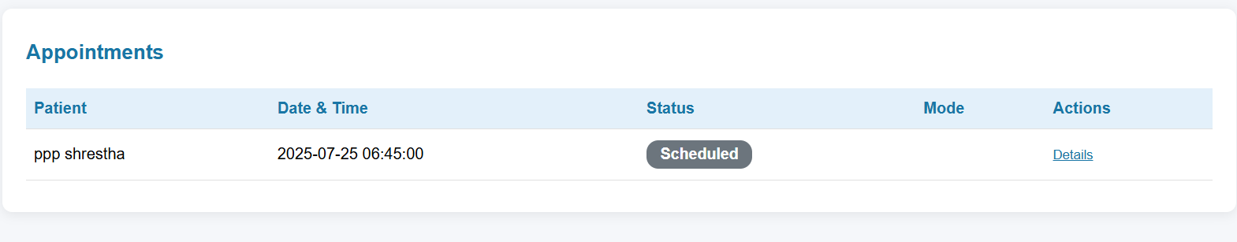
Patient Record
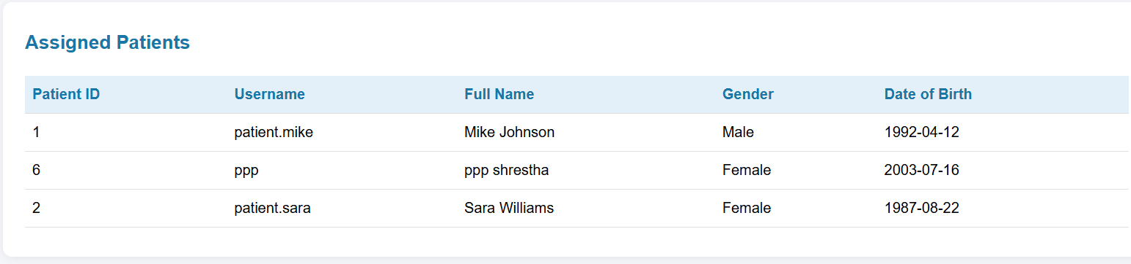

Receptionist dashboard
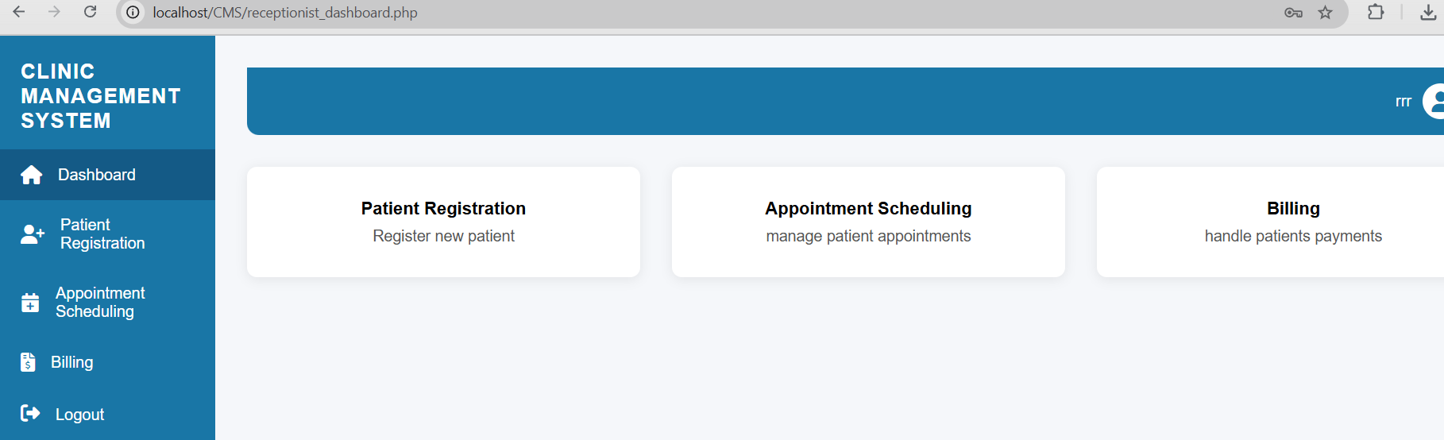
Appointment Scheduling
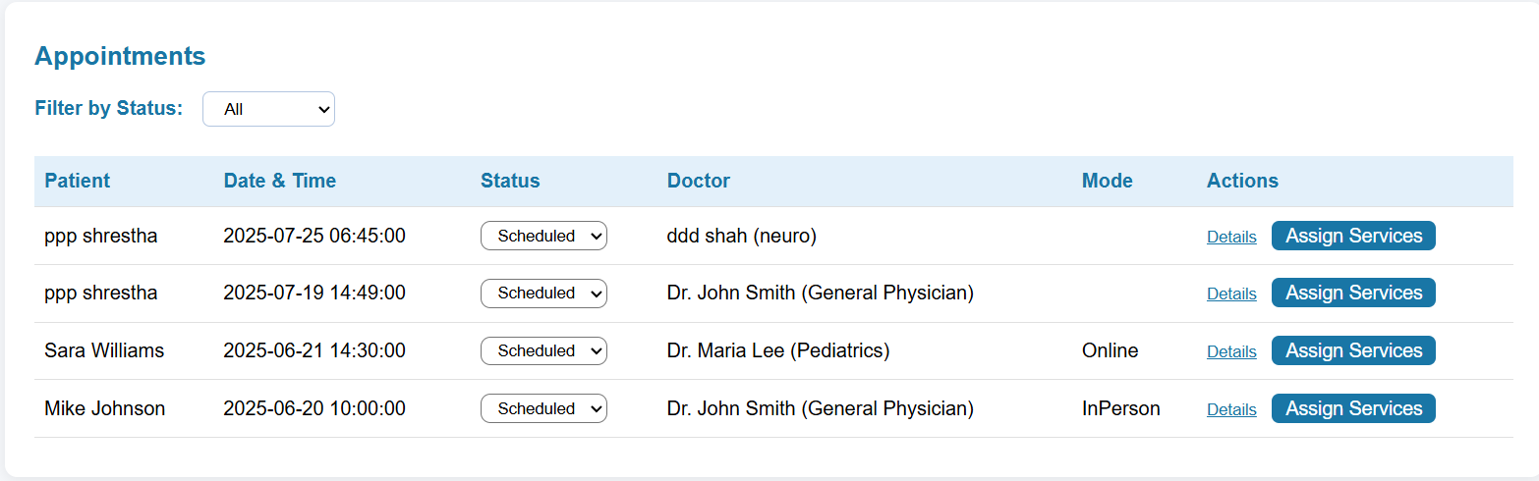

Billing
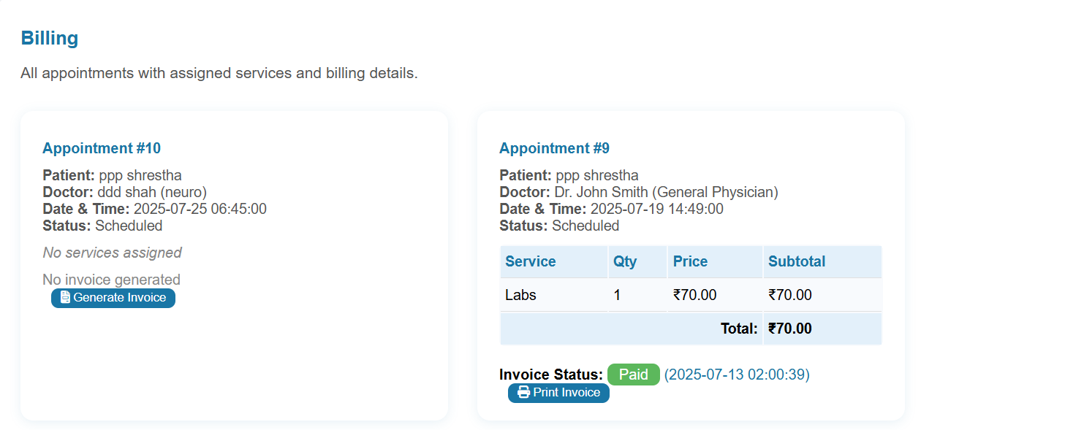

6. Conclusion
Finally, the Clinic Management System (CMS) development has made significant progress, moving from fundamental setup in Weeks 3 and 4 to advanced core feature execution in Weeks 5 and 6. Initially, the focus was on creating and configuring a relational MySQL database, as well as building backend logic for modules like user registration, patient management, and appointment scheduling.
During Weeks 5 and 6, significant developmental milestones were met. Key functionalities, including a patient billing system, multi-category service management (which includes consulting, procedures, laboratories, X-rays, and medicines), and invoice/payment monitoring, were effectively integrated. The system was further improved by replacing the planned SMS messages with a more effective email notification system that can deliver appointment confirmations, payment alerts, and vaccine reminders to patients.
All of these capabilities were created using PHP (inside XAMPP), with MySQL managing data persistence and phpMyAdmin used for backend database testing. The deployed modules are now functionally interconnected, resulting in a clear clinical process that spans patient registration, billing, and follow-up communications.
As the system evolves, the following phases will focus on improving the frontend user interface, introducing user login and role-based dashboards, and performing internal testing such as unit, integration, and UAT. The existing architecture and implementation demonstrate significant progress toward a dependable, secure, and user-centered clinical software solution.

